LOGIN FUNCTIOLITY:

ACCOUNT FUNCTIONALITY:

Funds Transfer:

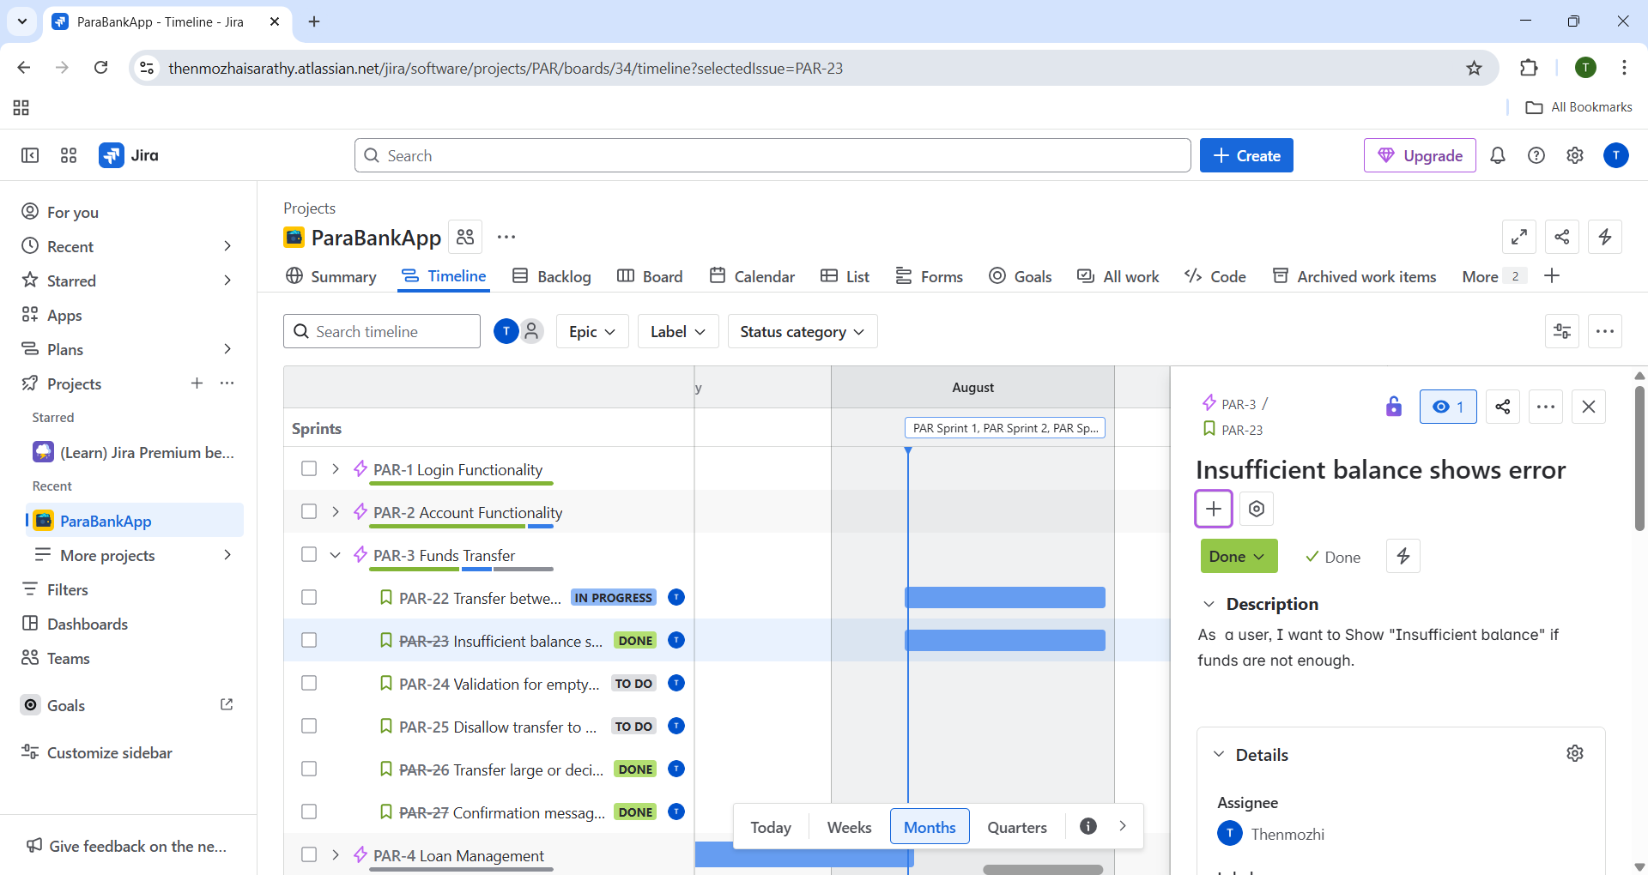

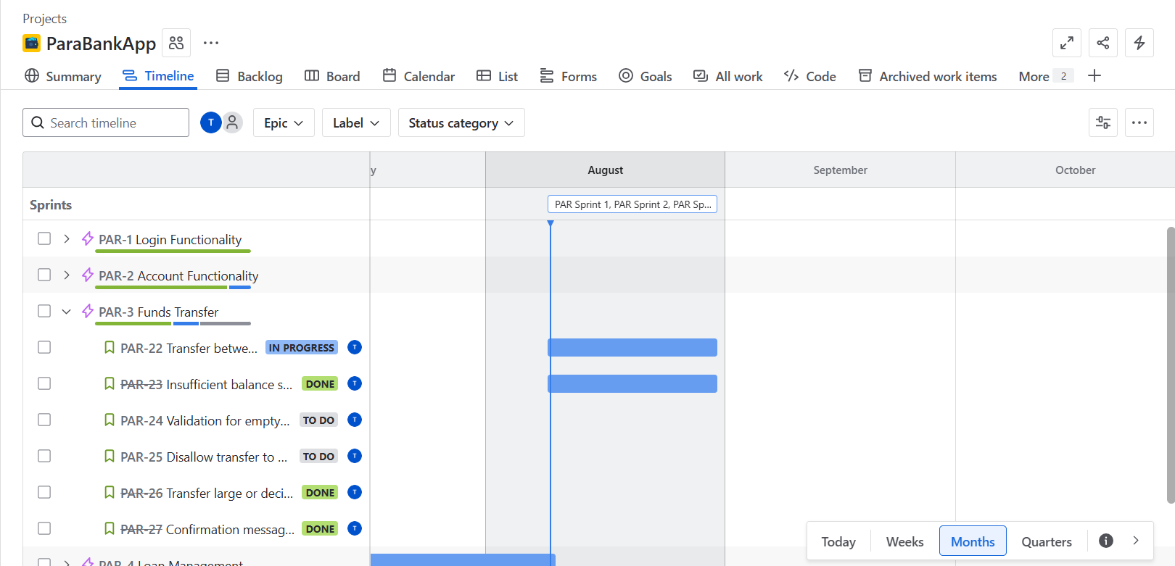

CUSTOMER SUPPORT FORM:

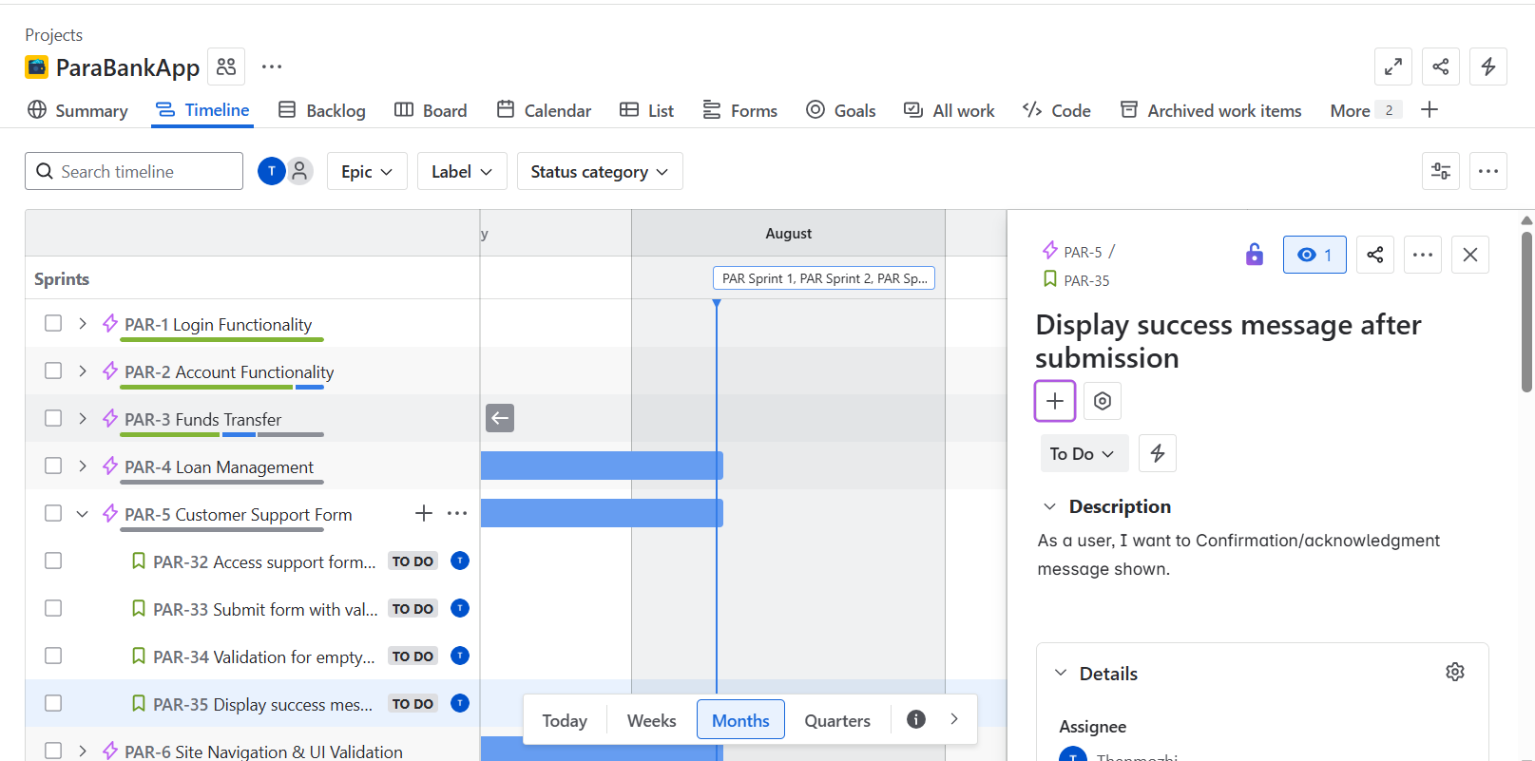

SITE NAVIGATION AND UI VALIDATION:

